# 概念描述

每一个界面都是以一个或者多个数据实体为中心的系列内容的展现。一个完整的界面包括如下的几个部分：

* 模板：规定界面的布局，定义标准位置，以提供内容的显示
* 子模板：对模板的局部修改，一个页面可以包含多个子模板，实现对模板多个地方的修改
* 样式：设定界面的样式风格，比如颜色，图片，预设文字等内容

# 用例描述

# 用例图

This template allows using PlantUML directly from MS Word 2010 without need to alter document templates or edit VBA macro's. MS Word Versions 2007 and 2013 might work, but are not tested.

## Example

@startuml

actor User

participant Word

participant PlantUML

User-->Word: Type text\nstartuml…enduml

User-->Word: Click [Add-ins:Uml]

activate Word

Word-->PlantUML: Generate pictures

activate PlantUML

PlantUML--//Word: Done

deactivate PlantUML

deactivate Word

User->User: ;-) pictures!

@enduml

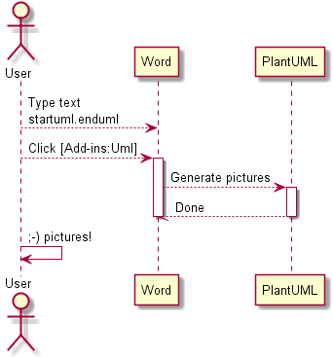

## Installation

First time:

* install this template in Word
  + copy this (docm) file in to %appdata%\Microsoft\Word\STARTUP
* install Plantuml.jar in %appdata%
* install GraphViz
  + <http://www.graphviz.org/Download_windows.php>
    - use installer if you have rights to install applications; this will install graphviz in your program files (x86)
    - use zip for portable installation
      * extract in %appdata%
      * (executable is then in %appdata%\release\bin\dot.exe)
  + if alternative portable installation, please set GRAPHVIZ_DOT  to location of DOT.EXE

restart Word. You now should have a PlantUML menu!

@startuml

actor User

participant Word

participant PlantUML

User-->Word: Type text\nstartuml…enduml

User-->Word: Click [Add-ins:Uml]

activate Word

Word-->PlantUML: Generate pictures

activate PlantUML

PlantUML--//Word: Done

deactivate PlantUML

deactivate Word

User->User: ;-) pictures!

@enduml



## Installation

First time:

* install this template in Word
  + copy this (dotm) file in to %appdata%\Microsoft\Word\STARTUP
  + note: .dotm = Word Doc Template (office 2007/2010) with Macro's enabled
* install Plantuml.jar in %appdata%
* install GraphViz
  + <http://www.graphviz.org/Download_windows.php>
    - use installer if you have rights to install applications; this will install graphviz in your program files (x86)
    - use zip for portable installation
      * extract in %appdata%
      * (executable is then in %appdata%\release\bin\dot.exe)
  + if alternative portable installation, please set GRAPHVIZ_DOT  to location of DOT.EXE
* restart Word. You now should have a PlantUML menu!

## Using

Once installed, a special menu (PlantUML) should be availabe in Word.

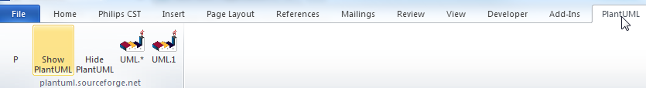

P =  : show paragraph marks

Show PlantUML: reveal (green text) of PlantUML image sources (for editing)

Hide PlantUML : hide source, just show generated pictures (before releasing a document for review/UCC)

UML.1 : Generate current diagram (cursor in green PlantUML definition)

UML.* : Generate all (note: this may take seconds up to a minute for 100+ pictures). Press Ctrl-Break to abort.

## About word template

This document contains VBA scripts (based on plantuml007.bas).

Improvements made by Adriaan van den Brand:

* Easy distribution and integration (as a word.docm)
* performance (no new documents created, direct writing of text files)
* fixed issue of images at wrong locations
* better sync with plantuml java (by using ShellandWait module)
* no unnecessary delays
* can be aborted with ctrl-breai

Known issues:

* autoformat (automatic bullets/arrows) are not compatible with plantuml
* formatting plantuml can be improved
* add-ins from previous version are still created (so 2 methods of invoking plantuml after first Uml.* run)

Contact:[adriaan.plantuml@gmail.com](mailto:adriaan.plantuml@gmail.com)

I appreciate feedback and improved versions.

@startuml

left to right direction

class WordTemplate {

by Adriaan van den Brand

+PlantUML.bas

+ShellAndWait.bas

---

UML.1()

UML.*()

ShowPlantUML()

HidePlantUML()

}

class PlantUML.jar {

}

class GraphViz.DOT

WordTemplate --|> PlantUML.jar

PlantUML.jar --|> GraphViz.DOT

@enduml

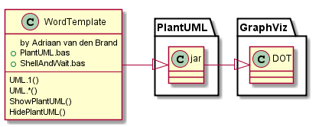

## Version info plantUML

The following picture should be updated when you select PlantUML (menu) UML.1 or UML.*

@startuml

version

@enduml

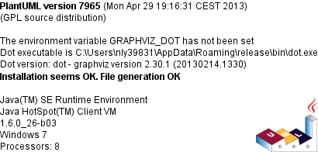

## Check for uppdates

@startuml

checkversion

@enduml

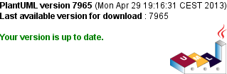

## License information

For license information of PlantUML, please check out <http://plantuml.sourceforge.net/>

The code below will generate a copyright image (if correctly installed)

@startuml

license

@enduml

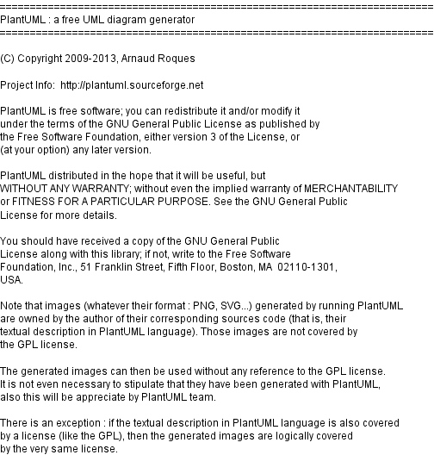

## VBA code Shellandwait

' By Chip Pearson, chip@cpearson.com, www.cpearson.com

' This page on the web site: www.cpearson.com/Excel/ShellAndWait.aspx

' 9-September-2008

(Public domain)

# Examples

See [http://plantuml.sourceforge.net](http://plantuml.sourceforge.net/) for more information and examples

## Basic sequence diagram

@startuml

title <u>Simple</u> communication example\non several lines

Alice -> Bob: Authentication Request

Bob -> Alice: Authentication Response

@enduml

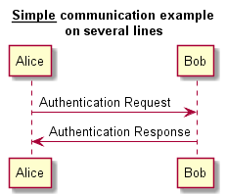

## Class example

@startuml

skinparam classAttributeIconSize 0

class Dummy {

-field1

#field2

~method1()

+method2()

}

@enduml

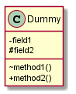

## Activity (parallel)

@startuml

start

if (multiprocessor?) then (yes)

fork

:Treatment 1;

fork again

:Treatment 2;

end fork

else (monoproc)

:Treatment 1;

:Treatment 2;

endif

@enduml

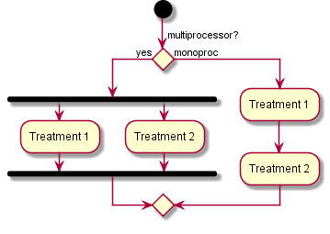

## Components

@startuml

package "Some Group" {

HTTP - [First Component]

[Another Component]

}

node "Other Groups" {

FTP - [Second Component]

[First Component] --> FTP

}

cloud {

[Example 1]

}

database "MySql" {

folder "This is my folder" {

[Folder 3]

}

frame "Foo" {

[Frame 4]

}

}

@enduml

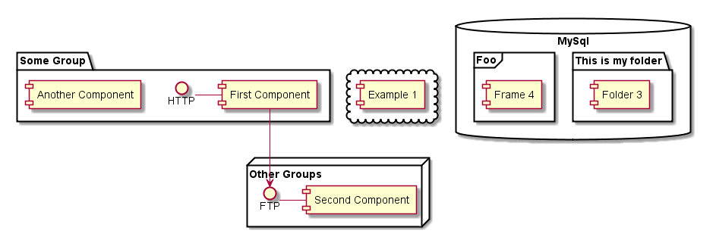

## Statechart

@startuml

scale 350 width

[*] --> NotShooting

state NotShooting {

[*] --> Idle

Idle --> Configuring : EvConfig

Configuring --> Idle : EvConfig

}

state Configuring {

[*] --> NewValueSelection

NewValueSelection --> NewValuePreview : EvNewValue

NewValuePreview --> NewValueSelection : EvNewValueRejected

NewValuePreview --> NewValueSelection : EvNewValueSaved

state NewValuePreview {

State1 -> State2

}

}

@enduml

